Ryan Rogers

Dr. Baylis

RF uWave Lab

10/13/19

Post-Lab Report 4

**Summary:** The purpose of this lab is to allow students the opportunity to design their own impedance matching networks based on unique load elements to match a 50 ohm transmission line. Each circuit will be designed to operate at 2GHz and will include only transmission lines and the load resistor element. The load resistor is “grounded” by an “RF short” which uses a third quarter-wavelength transmission line (the first being the 50 ohm line and the impedance matching line) to transform voltages at the end of the transmission line system to appear as a grounded short circuit. This alleviates the need for a via-hole to physically connect the end of the system to the ground node. The simulated circuits are then manufactured into practical physical components and measured to compare to simulations.

**

Figure : ADS Matching Circuit (140 ohms)

This circuit layout is similar to every other circuit produced in this lab, the only difference between this plot and any others, is the load (seen here as 140 ohm) which range from simple resistive elements to RL or RLC loads (the effects of more complex loads discussed later).

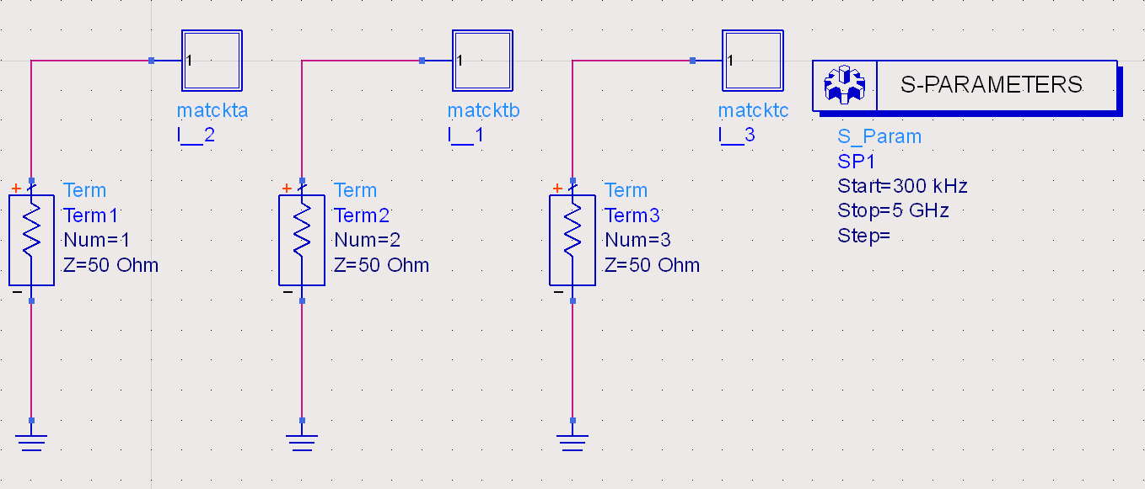

Figure : Simulation Setup for Matched T-Lines with 140, 200 and 75 ohm loads (left to right)

Figure : Transmission Waveforms from Figure 2 Setup

This waveform is generated by the networks fitted with purely resistive loads. Here we see that the circuit with the lowest impedance (75 ohms) has the largest bandwidth with the lowest dB measurement. Percent bandwidth calculation results are as follows:

Table : Percent Bandwidth Results

|  |  |
| --- | --- |
| Load (Ohms) | % BdWth |
| 75 | 85 |
| 200 | 35 |
| 140 | 25 |

Figure : 140 ohm Load with Inductive Element Included

Figure : 140 ohm Load with Inductive Element and Capacitive Compensation Element

Figure 4 shows the design circuit with a small inductive element to simulate real-world components that would have parasitic inductance in the circuit. Figure 5 shows this same circuit with a capacitor added in series to create a net reactance of zero with the parasitic inductive element.

Figure : Simulation Setup for "Realistic" Circuit Simulations

Figure : Transmission Waveforms from Figure 6 Setup

S(3,3) shows the plot of the ideal transmission circuit with no parasitic elements. Notice the minimum is obviously located at the design frequency. S(2,2) shows the plot of a circuit with parasitic inductive elements. This added inductance destroys the ability of the circuit to transmit at the design frequency. S(1,1) show the same realistic circuit with a compensating capacitor included. The minimum at the design frequency returns in this setup, however, it has a narrower bandwidth because the compensation is also designed to take effect at the design frequency.

Figure : Transmission Waveforms of Simulated and Physical Circuits

Both plots show the results of the same design( S(3,3) representing the simulation, S(4,4) the practical). Both have their minimums close to the design frequency of 2 GHz, However, the practical circuit shows undesirable results compared to its simulated counterpart, with overall higher measurements and less dramatic peaks. Reasons why this behavior could occur are: sub-ideal materials, human and machine error in manufacturing, fringing electric fields at the end of the transmission system and environmental forces line temperature or humidity. Each of these could extend of shorten the effective electrical length of the lines, thus throwing off matching behavior and resulting in less than ideal results.